Name: Farwa Ahmad

Roll number: MCSF19M024

Subject: Mobile Computing Week 6

GitHub link of Week 6 Applications: [MC_Progress_MCSF19M024/06WeekApplications at master · farwa-ahmad/MC_Progress_MCSF19M024 (github.com)](https://github.com/farwa-ahmad/MC_Progress_MCSF19M024/tree/master/06WeekApplications)

Lecture 10, 11 – Databases

1. Designed User Interface:

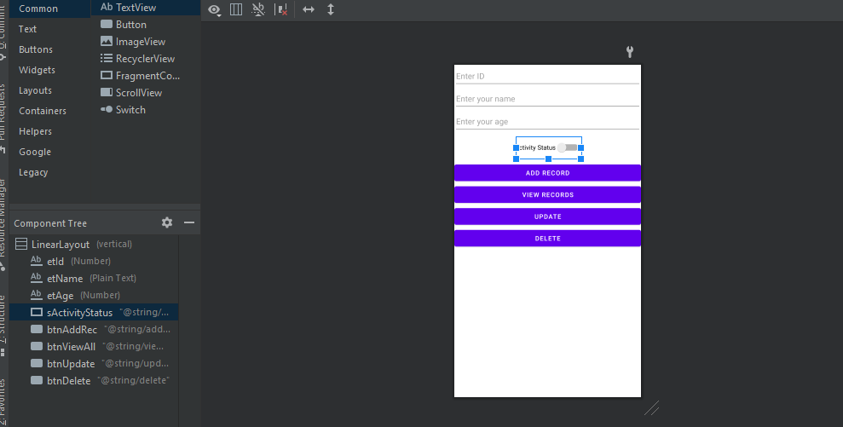

Code:

activity_main.xml

<?xml version="1.0" encoding="utf-8"?>

<LinearLayout xmlns:android="http://schemas.android.com/apk/res/android"

xmlns:app="http://schemas.android.com/apk/res-auto"

xmlns:tools="http://schemas.android.com/tools"

android:layout_width="match_parent"

android:layout_height="match_parent"

android:orientation="vertical"

tools:context=".MainActivity">

<EditText

android:id="@+id/etId"

android:layout_width="match_parent"

android:layout_height="50dp"

android:ems="10"

android:hint="@string/enter_id"

android:inputType="number"

android:importantForAutofill="no" />

<EditText

android:id="@+id/etName"

android:layout_width="match_parent"

android:layout_height="50dp"

android:ems="10"

android:hint="@string/enter_your_name"

android:inputType="textPersonName"

android:importantForAutofill="no" />

<EditText

android:id="@+id/etAge"

android:layout_width="match_parent"

android:layout_height="50dp"

android:ems="10"

android:hint="@string/enter_your_age"

android:inputType="number"

android:importantForAutofill="no" />

<androidx.appcompat.widget.SwitchCompat

android:id="@+id/sActivityStatus"

android:layout_width="wrap_content"

android:layout_height="wrap_content"

android:layout_gravity="center_horizontal"

android:layout_marginTop="8dp"

android:layout_marginBottom="8dp"

android:text="@string/activity_status" />

<Button

android:id="@+id/btnAddRec"

android:layout_width="match_parent"

android:layout_height="wrap_content"

android:text="@string/add_record" />

<Button

android:id="@+id/btnViewAll"

android:layout_width="match_parent"

android:layout_height="wrap_content"

android:text="@string/view_records" />

<Button

android:id="@+id/btnUpdate"

android:layout_width="match_parent"

android:layout_height="wrap_content"

android:text="@string/update" />

<Button

android:id="@+id/btnDelete"

android:layout_width="match_parent"

android:layout_height="wrap_content"

android:text="@string/delete" />

</LinearLayout>

1. Created Java Classes named DatabaseHelper and Model in package folder:

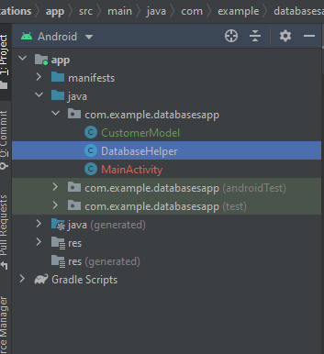

1. Extended DatabaseHelper class with SQLiteOpenHelper

Code:

DatabaseHelper.java

package com.example.databasesapp;

import android.content.ContentValues;

import android.content.Context;

import android.database.Cursor;

import android.database.sqlite.SQLiteDatabase;

import android.database.sqlite.SQLiteOpenHelper;

import androidx.annotation.Nullable;

public class DatabaseHelper extends SQLiteOpenHelper {

public static final String *DATABASE_NAME* = "Customer.db";

public static final String *TABLE_NAME* = "Customer_table";

public static final String *CUSTOMER_ID* = "Customer_ID"; //Column names

public static final String *CUSTOMER_NAME* = "Customer_Name";

public static final String *CUSTOMER_AGE* = "Customer_Age";

public static final String *CUSTOMER_ACTIVITY* = "Customer_Activity_Status";

public DatabaseHelper(@Nullable Context context) {

super(context, *DATABASE_NAME*, null, 1);

}

@Override

public void onCreate(SQLiteDatabase db) {

String createTableStatement = "CREATE TABLE " + *TABLE_NAME*

+ "(" + *CUSTOMER_ID* + " INTEGER PRIMARY KEY AUTOINCREMENT, "

+ *CUSTOMER_NAME* +" TEXT," + *CUSTOMER_AGE* + " INTEGER," + *CUSTOMER_ACTIVITY*+ " BOOL)";

db.execSQL(createTableStatement);

}

@Override

public void onUpgrade(SQLiteDatabase db, int oldVersion, int newVersion) {

db.execSQL("DROP TABLE IF EXISTS "+ *TABLE_NAME*);

onCreate(db);

}

public boolean insertData(String name, int age, boolean activityStatus)

{

SQLiteDatabase db = this.getWritableDatabase();

ContentValues cv = new ContentValues();

cv.put(*CUSTOMER_NAME*, name);

cv.put(*CUSTOMER_AGE*, age);

cv.put(*CUSTOMER_ACTIVITY*, activityStatus);

long result = db.insert(*TABLE_NAME*,null,cv);

if(result == -1)

return false;

else

return true;

}

public Cursor getAllData()

{

SQLiteDatabase db = this.getReadableDatabase();

Cursor result = db.rawQuery("SELECT * FROM "+*TABLE_NAME*,null);

return result;

}

public boolean updateData(String id, String name, String age, boolean activityStatus)

{

SQLiteDatabase db = this.getWritableDatabase();

ContentValues contentValues = new ContentValues();

contentValues.put(*CUSTOMER_ID*,id);

contentValues.put(*CUSTOMER_NAME*,name);

contentValues.put(*CUSTOMER_AGE*,age);

contentValues.put(*CUSTOMER_ACTIVITY*,activityStatus);

db.update(*TABLE_NAME*, contentValues, "ID=?", new String[]{id});

return true;

}

public Integer deleteData(String id)

{

SQLiteDatabase db = this.getWritableDatabase();

return db.delete(*TABLE_NAME*,"ID=?",new String[]{id});

}

}

1. Code of MainActivity.java

package com.example.databasesapp;

import androidx.appcompat.app.AlertDialog;

import androidx.appcompat.app.AppCompatActivity;

import android.database.Cursor;

import android.os.Bundle;

import android.view.View;

import android.widget.Button;

import android.widget.ListView;

import android.widget.Switch;

import android.widget.TextView;

import android.widget.Toast;

public class MainActivity extends AppCompatActivity {

TextView etName, etAge, etId;

Button btnAddRec, btnViewAll, btnUpdate, btnDelete;

Switch sActivityStatus;

//ListView lvDetail;

DatabaseHelper myDb;

@Override

protected void onCreate(Bundle savedInstanceState)

{

super.onCreate(savedInstanceState);

setContentView(R.layout.*activity_main*);

etName = findViewById(R.id.*etName*);

etAge = findViewById(R.id.*etAge*);

etId.findViewById(R.id.*etId*);

btnAddRec = findViewById(R.id.*btnAddRec*);

btnViewAll = findViewById(R.id.*btnViewAll*);

sActivityStatus = findViewById(R.id.*sActivityStatus*);

btnUpdate = findViewById(R.id.*btnUpdate*);

btnDelete = findViewById(R.id.*btnDelete*);

//lvDetail = findViewById(R.id.lvDetail);

myDb = new DatabaseHelper(this);

btnUpdate.setOnClickListener(new View.OnClickListener() {

@Override

public void onClick(View v) {

boolean isUpdated = myDb.updateData(etId.getText().toString(),

etName.getText().toString(),etName.getText().toString(),

sActivityStatus.isChecked());

if(isUpdated==true)

Toast.*makeText*(MainActivity.this,"Data updated",Toast.*LENGTH_LONG*).show();

else

Toast.*makeText*(MainActivity.this,"No data updated",Toast.*LENGTH_LONG*).show();

}

});

btnDelete.setOnClickListener(new View.OnClickListener() {

@Override

public void onClick(View v) {

Integer isDeleted = myDb.deleteData(etId.getText().toString());

if(isDeleted>0)

Toast.*makeText*(MainActivity.this,"Data deleted",Toast.*LENGTH_LONG*).show();

else

Toast.*makeText*(MainActivity.this,"No data deleted",Toast.*LENGTH_LONG*).show();

}

});

btnAddRec.setOnClickListener(new View.OnClickListener() {

@Override

public void onClick(View v)

{

boolean isInserted = myDb.insertData(etName.getText().toString(),

Integer.*parseInt*(etAge.getText().toString()),

sActivityStatus.isChecked());

if(isInserted == true)

Toast.*makeText*(MainActivity.this, "Data Inserted",Toast.*LENGTH_SHORT*).show();

else

Toast.*makeText*(MainActivity.this, "Error", Toast.*LENGTH_SHORT*).show();

/*try

{

CustomerModel customerModel = new CustomerModel(etName.getText().toString(),

Integer.parseInt(etAge.getText().toString()),

sActivityStatus.isChecked(),1);

Toast.makeText(MainActivity.this, "Data Inserted",Toast.LENGTH_SHORT).show();

}

catch (Exception e)

{

Toast.makeText(MainActivity.this, "Error", Toast.LENGTH_SHORT).show();

}

*/

}

});

btnViewAll.setOnClickListener(new View.OnClickListener() {

@Override

public void onClick(View v) {

Toast.*makeText*(MainActivity.this, "View Record Clicked",Toast.*LENGTH_SHORT*).show();

Cursor result = myDb.getAllData();

if(result.getCount() == 0)

{

showMessage("Error","Nothing Found");

return;

}

StringBuffer buffer = new StringBuffer();

while(result.moveToNext())

{

buffer.append("ID: "+result.getString(0)+"\n");

buffer.append("Name: "+result.getString(1)+"\n");

buffer.append("Age: "+result.getString(2)+"\n");

buffer.append("Activity Status: "+result.getString(3)+"\n\n");

}

result.close();

myDb.close();

showMessage("Data",buffer.toString());

}

public void showMessage(String title, String message)

{

AlertDialog.Builder builder = new AlertDialog.Builder(MainActivity.this);

builder.setCancelable(true);

builder.setTitle(title);

builder.setMessage(message);

builder.show();

}

});

}

}